TRADING UP
Inside Exchanges' Race
To Invent New Bets
Amid a Merger Wave,
They Seek Products
With Fatter Margins
By AARON LUCCHETTI and ALISTAIR MACDONALD
July 6, 2007; Page A1
To understand why financial markets from Chicago to Sydney are scrambling to merge with each other, step inside the tidy office of John "J-Lab" Labuszewski overlooking the Chicago River.
Mr. Labuszewski, a goateed researcher known for his scientific demeanor, is part of a growing movement transforming global markets. He works at the Chicago Mercantile Exchange designing ever more exotic "derivatives" -- futures and options contracts that let investors bet on anything from the temperature in Osaka to the next move in home prices in Denver.
• What's New: Derivatives trading has soared in recent years, creating a frenzy for exchanges looking for the next hot financial product.
• The Background: Increasing competition hurt some exchanges' profit margins, making the new derivatives trading products more important.
• Fueling the Change: Technology has transformed trading systems, and growth of private-money pools has spurred demand for new investment opportunities.
Global derivatives trading on exchanges has grown nearly 30% a year on average since 2001 to reach almost 12 billion contracts last year. The value of exchange-traded financial derivatives measured by the Bank for International Settlements is now about $87 trillion; that's more than double the value in 2003. Mr. Labuszewski's exchange, known as the Merc, surpassed the New York Stock Exchange in market value in 2003. This all helps explain why exchanges are in a merger frenzy: They want one another's hot trading products.
The four biggest futures exchanges have launched more than 300 new derivatives since 1999 -- about 40% of them from Mr. Labuszewski's team -- and winning formulas are getting harder to find. Far more attempts become flops than hits. So the exchanges are in a race to come up with the next successes -- and to acquire rivals to get control of their star products.
Until the past few years, most stock and commodity exchanges were clubby nonprofits where buyers and sellers simply met to trade. But as technology transformed trading and increased competition, at various points the exchanges -- especially the stock exchanges -- saw their margins fall. Most exchanges became for-profit corporations and invested in giant computer trading systems to survive by lowering their costs.
The new trading systems also made experimentation more affordable, and the growth of private-money pools looking for new investments made the efforts potentially more lucrative. With derivatives, the first exchange to launch a popular product usually ends up virtually owning the market for it -- making the trading fees more profitable because they're protected from competition.
Now, exchanges as a group make most of their money by developing and trading their own futures products, not by trading stocks -- a big shift from just six years ago. Futures accounted for about three-quarters of the combined profits of the seven publicly traded U.S. exchanges in the first quarter of this year, according to an estimate by brokerage firm Sandler O'Neill & Partners. That's up from about half of those same exchanges' profits in 2001, the firm says.
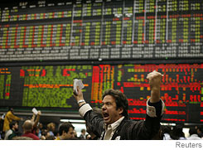
A trader at the Chicago Mercantile Exchange, which has launched futures contracts that allow investors to bet on the direction of the Chinese yuan, inflation in Europe and snowfall in the U.S.
Exchanges have created "product development" positions -- "just like someone at Ford, Nestlé or Mars," says Amanda Sudworth, director of interest-rate products for the London-based Euronext.liffe derivatives exchange. Mr. Labuszewski, the Merc's managing director of research and product development, has launched futures contracts that allow investors to bet on the direction of the Polish zloty and the Chinese yuan, the level of inflation in Europe and the amount of snowfall on the East Coast.
Among the failed Merc efforts was a contract betting on the rate of personal bankruptcies, withdrawn for lack of buyers. A possible coming attraction: a derivative that lets investors bet on the box-office take of new movies. "We like to think we leave no stone unturned," says Mr. Labuszewski, 50 years old.
Many of the exchanges' derivatives were first developed privately for big clients by giant Wall Street financial firms such as Goldman Sachs Group Inc. and J.P. Morgan Chase & Co. That has created some tension, as exchanges increasingly seek to adapt the financial firms' products for a broader market. The Merc "competes with us, and that is the problem," Patrice Blanc, head of the brokerage unit at Paris-based Société Générale, a major trading house, said in a February interview. Yet the exchanges also count on the Wall Street firms to consult on their new derivatives products -- and to buy them, for themselves or for clients.
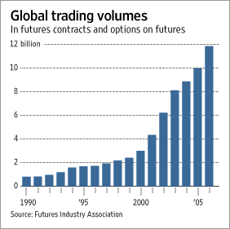
Some Wall Street firms have opposed a Merc bid to take over CBOT Holdings Inc., which owns the oldest U.S. futures exchange, the Chicago Board of Trade. The Merc is in a bidding war with Atlanta-based rival IntercontinentalExchange Inc. If the Merc prevails in a CBOT shareholder vote Monday, it would likely again rank as the world's largest exchange by market value; recently Germany's Deutsche Börse and the NYSE have been outpacing it. (The U.S. Futures Exchange has launched a futures contract inviting bets on the outcome.)
The Wall Street firms raised antitrust concerns, warning a merged exchange would grow too powerful, but the Department of Justice last month allowed the Merc bid to proceed. NYSE also has jumped into the derivatives business, buying Amsterdam-based Euronext NV in April in a $14 billion deal. The deal included the Euronext.liffe exchange, which also rocketed the NYSE from almost nowhere to No. 4 in global futures trading volume behind the Merc, Frankfurt's Eurex AG and CBOT.
Olive Crops
Derivatives, which Aristotle described being used in ancient Greece to bet on olive crops, have been traded on exchanges since the 1600s. In a classic transaction, a farmer signs a contract to sell his crop in the future at a price set today, to avoid uncertainty. Speculators then trade those so-called futures contracts to bet on price moves. They're dubbed derivatives because they "derive" their value from the price movements of the underlying commodity.
Futures trading poses significant risk, partly because the contracts -- which represent promises by the parties, not actual ownership of the assets -- can be entered into with a small initial payment even though the contracts themselves are often very large. Some contracts have been banned after they were associated with market disruptions. Futures contributed to a celebrated Dutch mania of the 1630s, when tulips became fashionable in European cities and speculators bet wrongly that prices would keep soaring. Futures traders appeared to gain control of the U.S. onion inventory in the 1950s, the Maine potato market in the 1970s and soybeans in the 1980s.
But in the 1970s and 1980s, big swings in inflation and then in interest rates -- along with newly floating currency prices -- spurred an explosion in demand for financial futures, to hedge against those shifts just like shifts in farm prices. Next, the rise of stock-index mutual funds prompted new futures on benchmarks like the Standard & Poor's 500-stock index, now one of the Merc's most popular products and one that helped push financial-futures trading volume past commodity-futures volume.
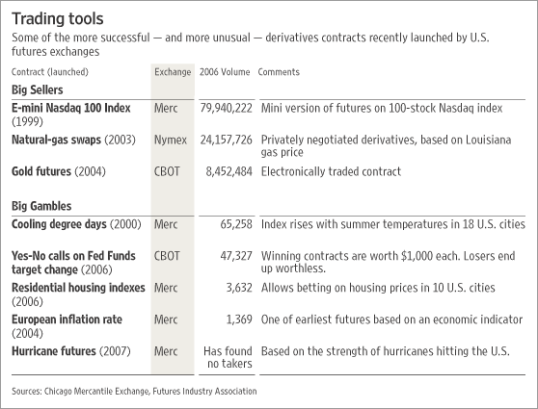
To pass regulatory muster in the U.S., exchange-traded derivatives aren't supposed to simply work like forms of gambling -- they must have economic meaning for at least some customers, who use them much like insurance against various business risks. Banks, for instance, may want to hedge against their customers' credit worsening. Multinational corporations need to manage their exposure to inflation around the world.
In 1999 the Merc also began launching a series of derivatives tied to the weather -- an idea that hadn't yet swept Wall Street. The Merc's chief economist at the time, Fred Arditti, had the idea about a year earlier after getting caught in a Chicago winter storm, which prompted him to wonder what firms might want to protect themselves financially against the risk that bad weather would hurt their business.
That led to the first weather contract devised by Mr. Labuszewski's Merc team. It was based on the number of "heating degree days," a gauge roughly tied to the extra money a factory owner might need to spend to heat a plant during a particularly cold winter. The concept was slow to take off, but now the Merc's weather futures are outselling some traditional farm-product contracts, including pork bellies.
In 2000, Washington loosened regulations and gave exchanges new leeway to sell futures based on more esoteric concepts -- such as events -- as the big Wall Street financial firms already were doing. Mr. Labuszewski's Merc team rolled out event-triggered weather contracts involving snowfall, frost and hurricanes. Through a joint venture, the Merc also tackled derivatives on economic events including changes in the consumer-price index, U.S. nonfarm payrolls, retail-sales figures and jobless claims. But none were as successful as bets on the weather. (The economic-event derivatives were discontinued last week after the partnership dissolved over time.)
As exchanges find new triumphs more elusive, they're casting their nets farther. Their latest focus is on derivatives based on companies' credit and solvency. But Wall Street and global financial firms, which offer their own versions, are proving especially resistant to exchanges getting into that business -- which makes it harder to score successes.
In 2003 a Wall Street trade group, the International Swaps and Derivatives Association, published an 84-page book of standards governing the immensely complex credit-futures contracts -- but it was aimed at ISDA member banks, not exchanges. Nevertheless, Mr. Labuszewski and his counterparts at other exchanges raced to be the first to get into the business.
Mr. Labuszewski, who grew up in the Chicago suburb of Elmhurst, started his career at the Chicago Board of Trade in 1979 after earning his MBA at the University of Illinois. He now calls that era "the dark ages" before financial futures took off. He then worked at Nikko Securities, where he was a key player in bringing big Japanese investors into U.S. futures markets, says Jack Bouroudjian, a former colleague at Nikko who also has served on the Merc board. Since the Merc "discovered" him in 1998, Mr. Bouroudjian says, Mr. Labuszewski helped launch a raft of stock-index futures generating hundreds of millions of trades.
'Derivatives Supermarket'
Mr. Labuszewski, author or co-author of four books on derivatives, calls the exchange a "derivatives supermarket" that can make money from a large variety of small transactions. His "J-Lab" nickname reflects his experimenter's role, and personality, in the eyes of some colleagues. "He doesn't strike me as a guy who wheels and deals," says Jamie Selway, an executive at New York brokerage firm White Cap Trading. "He's in there with a beaker of steam, trying to create."
Mr. Labuszewski's first proposal for the new credit-futures market was a contract based on an index of credit derivatives sold by Wall Street firms -- in other words, a derivative derived from an index of derivatives.
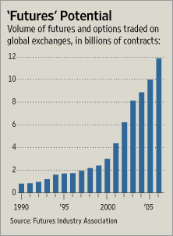
The plan met resistance during a summer 2005 meeting with representatives of the investment-bank consortium that controls the index, CDS IndexCo. Brad Levy of Goldman, the consortium's chairman, told Mr. Labuszewski there was no demand for the product. "These are early days. Let's see how the market develops," Mr. Levy said at the meeting at Goldman headquarters in lower Manhattan, according to people familiar with the matter.
Mr. Labuszewski soon switched gears. A small group of Merc executives, meeting in their downtown Chicago office and a Starbucks around the corner, started batting around the idea of creating a Merc index of potential company bankruptcies. Among 32 companies, if any filed for bankruptcy the buyer's position would rise in value and the seller's would fall. The main obstacle was figuring out how to put a relative value on each bankrupt company based on its remaining assets. It can take months of fighting in bankruptcy court to settle that issue. Mr. Labuszewski's answer was simple but unorthodox: The Merc designed the derivative to basically pay the seller 40 cents on the dollar of the bankrupt company's bonds, no matter the balance sheet of the particular company.
Mr. Labuszewski and his colleagues started shopping the idea among potential buyers such as hedge funds, and also approached Wall Street firms in hopes they would agree to buy it and offer it to clients alongside their own private contracts with similar functions. Again, the news wasn't good. Traders at banks including J.P. Morgan, Goldman and Lehman Brothers Holdings Inc. didn't buy into the one-size-fits-all payout. They said more sophisticated handicapping of companies' post-bankruptcy value was needed.
Meanwhile, a rival exchange -- Eurex, a derivatives unit owned by Deutsche Börse and Swiss exchange operator SWX Group -- was doing just that. It was about to beat Mr. Labuszewski to market with a credit-derivative index of European companies. The Eurex effort was headed by Brendan Bradley, who avoided Mr. Labuszewski's 40-cents-per-dollar approach by saying an auction among buyers and sellers of the private contracts would determine how much money would change hands in the event of a bankruptcy. But most investment banks declined to trade Mr. Bradley's version as well. They were "protecting their vested interests," Mr. Bradley says.
The firms say the auction idea wouldn't work for some smaller companies' bankruptcies. The ISDA, which put out the 2003 book of standards, expressed concern the Eurex product could be used to manipulate corporate bond prices around the time of a bankruptcy.
Mr. Bradley's derivative, called iTraxx Europe futures, started trading on Eurex in March anyway, but has won only a few dozen buyers. "It is very hard to improve on" banks' own trading of credit futures, Guy America, the European head of credit trading at J.P. Morgan, said soon after the contracts were launched.
The Merc didn't launch its own credit index until this June. It had to wait to find out who would police the product -- the U.S. Commodity Futures Trading Commission, which oversees futures exchanges, or the Securities and Exchange Commission, which increasingly has gotten involved as credit futures are tied more closely to securities or bonds. The CFTC ultimately took charge, but the product has had no trades yet.
New derivatives often take time to build momentum. Heating-oil futures took years to become successful, as did the Merc's huge Eurodollars derivative, a contract used for hedging interest rates on U.S. dollars deposited in commercial banks outside the U.S.
Any new derivative travels "a long and winding road," says Mr. Labuszewski. "We had at least nine different pork-belly contracts before we got it right."
Write to Aaron Lucchetti at aaron.lucchetti@wsj.com and Alistair MacDonald at alistair.macdonald@wsj.com

